<https://www.theaustralian.com.au/world/free-church-from-toxic-nightmare-george-pells-last-warning-to-pope-francis/news-story/26409b3e1b21e3ccb2c3a334b1aa0665>

‘Free church from toxic nightmare’: George Pell’s last warning to Pope Francis

[[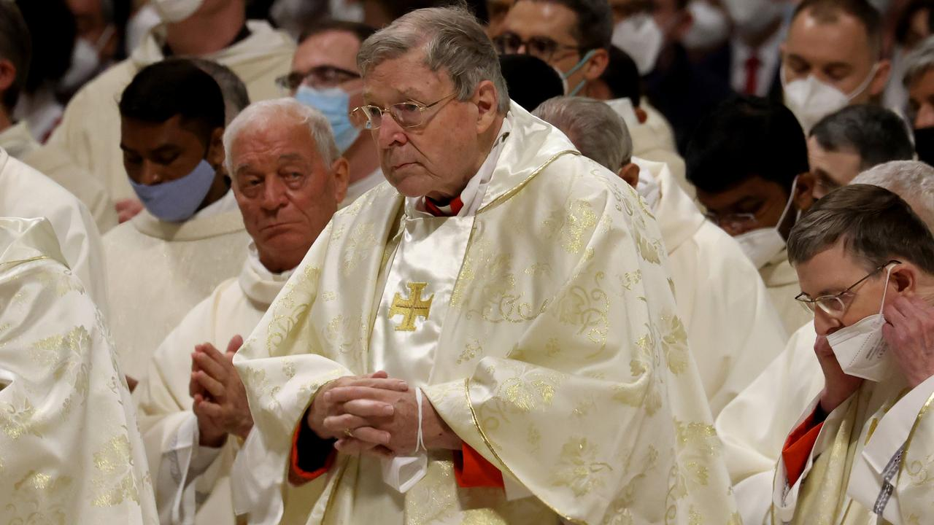](https://content.api.news/v3/images/bin/3d46524440c8aa0515604aa887180d3d?width=1280)Cardinal George Pell attends the Easter Vigil Mass in St. Peter's Basilica. Picture: etty Images.](https://content.api.news/v3/images/bin/3d46524440c8aa0515604aa887180d3d?width=1280)

* **By**[**JACQUELIN MAGNAY**](https://www.theaustralian.com.au/author/jacquelin-magnay)

EUROPE CORRESPONDENT

* 11:53AM JANUARY 12, 2023
* [259 COMMENTS](https://www.theaustralian.com.au/world/free-church-from-toxic-nightmare-george-pells-last-warning-to-pope-francis/news-story/26409b3e1b21e3ccb2c3a334b1aa0665#coral)

In what would be some of his last words, Cardinal George Pell warned Pope Francis and the Catholic Synod of Bishops shortly before he died that its current revisions about synodality – the mission of the church – were a toxic nightmare couched in Neo-Marxist jargon and that the process being undertaken was liable to manipulation.

Cardinal Pell authored a hard-hitting article in the right wing magazine Spectator about the forthcoming “Synod on Synodality”, which would have raised many high-level debates within the Vatican, if it had not been for his sudden death on Wednesday.



The Front

**Cardinal George Pell’s complicated legacy**

00:00

13:39

In the article, Cardinal Pell wrote that the Catholic Synod of Bishops was busy constructing what they think of as “God’s dream” of synodality, in a booklet entitled “Enlarge the Space of your Tent” which he said accommodated not the newly baptised — those who have answered the call to repent and believe — but anyone who might be interested enough to listen.

He wrote that the recent update of the good news, “synodality” as a way of being for the Church was not to be defined, but just to be lived.

[[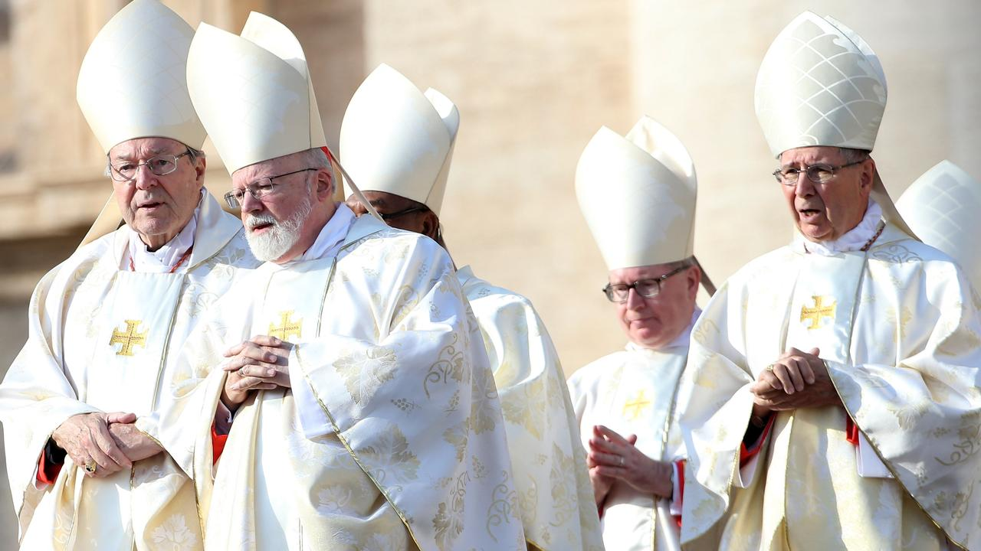](https://content.api.news/v3/images/bin/187a2f14e5f6c2c6168c1d5fdd61e167)Cardinal George Pell (L), Archbishop of Boston Cardinal Sean Patrick O'Malley (C) and Former archbishop of Los Angeles cardinal Roger Mahony (R) attend the closing of the Jubilee of Mercy in St Peter's Square. Picture: Getty Images.](https://content.api.news/v3/images/bin/187a2f14e5f6c2c6168c1d5fdd61e167)

Denouncing the booklet as “one of the most incoherent documents ever sent out from Rome,” the Cardinal criticised it for including “neo-Marxist jargon” about exclusion, alienation, identity, marginalisation, the voiceless, LGBTQ, while Christian notions of forgiveness, sin, sacrifice, healing, redemption were displaced.

“Why the silence on the afterlife of reward or punishment, on the four last things; death and judgment, heaven and hell?” he queried, attacking the update as a “potpourri outpouring of New Age goodwill”.

[[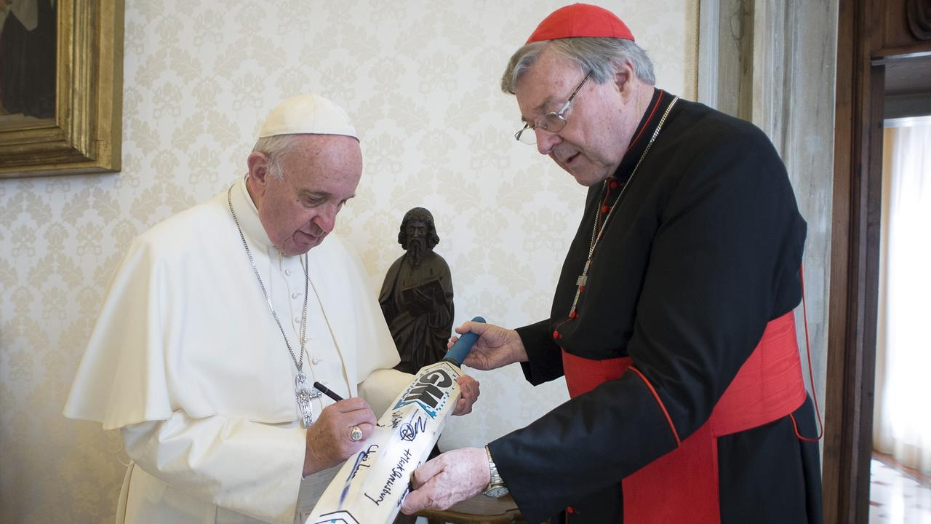](https://content.api.news/v3/images/bin/668ed4f469443f0a2cfba0b38e23756d)Pope Francis signs a cricket bat of Canterbury cricket team received from Cardinal George Pell at the Vatican. Picture: Reuters.](https://content.api.news/v3/images/bin/668ed4f469443f0a2cfba0b38e23756d)

READ MORE: [Even in jail, support amid the hostility](https://www.theaustralian.com.au/nation/george-pell-even-in-jail-support-amid-the-hostility/news-story/1ef8e9bd1cec028f46b1c23420f0c6ea) | [Great churchman, fine priest and good Christian soul](https://www.theaustralian.com.au/nation/george-pell-polarising-figure-remembered-as-a-great-churchman-fine-priest-and-good-christian-soul/news-story/7d5cbd35300fcf99e89a3025a29316bd) | [Pope to preside over Pell Requiem Mass](https://www.theaustralian.com.au/world/pope-to-preside-over-george-pell-requiem-mass/news-story/1269295b24500e7c942a344c1a59ab7b) | [George Pell: Last farewell for God’s strong man](https://www.theaustralian.com.au/nation/last-farewell-for-gods-strong-man/news-story/be29448d0b7174f33e51b9e1ca736a69) | [George Pell, the public and private colossus](https://www.theaustralian.com.au/commentary/george-pell-the-public-and-private-colossus/news-story/85e44cfaf67fffb13c68e00abf92813c) | [Thoughts with ‘man of faith’ as well as survivors of abuse](https://www.theaustralian.com.au/nation/george-pell-thoughts-with-man-of-faith-as-well-as-survivors-of-abuse/news-story/0698f6aa68930553151dbb0dee4a0ad0) |

“It is not a summary of Catholic faith or New Testament teaching. It is incomplete, hostile in significant ways to the apostolic tradition and nowhere acknowledges the New Testament as the Word of God, normative for all teaching on faith and morals. The Old Testament is ignored, patriarchy rejected and the Mosaic Law, including the Ten Commandments, is not acknowledged,” he wrote.

Cardinal Pell’s words will be seen by many as criticism of the Pope himself, since the Synod of Synodality was his pet project. It will also be taken up by the more conservative elements of the church to press for further revisions to the working document.

It was published as the Vatican confirmed that Francis was expected to preside over a Requiem Mass for the Cardinal, set down for either Friday or Monday.

The Vatican was this morning deliberating which date to hold the Requiem Mass, which could take place in St Peter’s Basilica in the Vatican City.

There were initial plans to hold the mass on Friday, but this has been suspended after the Catholic Church in Australia advised that any attendees from Australia would struggle to make it on time. Officials are looking to see if it can be scheduled on Monday but nothing has been confirmed.

Francis, 86, would normally conduct the requiem mass for a Cardinal, but because of his own ill health, he is set to undertake a similar role to that he played in the funeral of Emeritus Pope Benedict earlier this month, presiding over the proceedings, a Vatican source told The Australian.

Cardinal Pell had also pointed out that no matter what the synod’s participants: lay, religious, priest or bishop had come up with, they were only allowed to pass on views to the Holy Father for him to decide.

He said this was “not due process and is liable to manipulation”, saying that it should be “judged by the whole people of God and especially by the bishops with and under the Pope”.

In his final plea he said “This working document needs radical changes. The bishops must realise that there is work to be done, in God’s name, sooner rather than later.”

[**JACQUELIN MAGNAY**](https://www.theaustralian.com.au/author/jacquelin-magnay)

[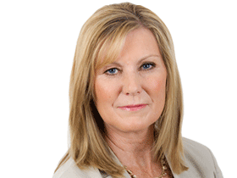](https://www.theaustralian.com.au/author/jacquelin-magnay)

 EUROPE CORRESPONDENT

Jacquelin Magnay is the Europe Correspondent for The Australian, based in London and covering all manner of big stories across political, business, Royals and security issues. She is a George Munster and Walkley Aw... [Read more](https://www.theaustralian.com.au/author/jacquelin-magnay)

Share this article

* [Facebook](https://facebook.com/sharer.php?u=https%3A%2F%2Fwww.theaustralian.com.au%2Fworld%2Ffree-church-from-toxic-nightmare-george-pells-last-warning-to-pope-francis%2Fnews-story%2F26409b3e1b21e3ccb2c3a334b1aa0665&t=Pell%20warned%20Pope%20over%20church%E2%80%99s%20%E2%80%98toxic%20nightmare%E2%80%99)
* [Twitter](https://twitter.com/intent/tweet?url=https%3A%2F%2Fwww.theaustralian.com.au%2Fworld%2Ffree-church-from-toxic-nightmare-george-pells-last-warning-to-pope-francis%2Fnews-story%2F26409b3e1b21e3ccb2c3a334b1aa0665&text=Pell%20warned%20Pope%20over%20church%E2%80%99s%20%E2%80%98toxic%20nightmare%E2%80%99)
* [Email](mailto:?subject=Pell%20warned%20Pope%20over%20church%E2%80%99s%20%E2%80%98toxic%20nightmare%E2%80%99&body=https%3A%2F%2Fwww.theaustralian.com.au%2Fworld%2Ffree-church-from-toxic-nightmare-george-pells-last-warning-to-pope-francis%2Fnews-story%2F26409b3e1b21e3ccb2c3a334b1aa0665)

**More stories on this topic**

* [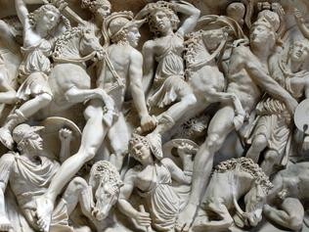](https://www.theaustralian.com.au/weekend-australian-magazine/columnists/is-there-a-crate-of-penises-in-the-vaticans-cellars/news-story/6c7d796fd5d2a2da86595f6137103170)

[Is there a crate of marble appendages in the Vatican’s cellars?](https://www.theaustralian.com.au/weekend-australian-magazine/columnists/is-there-a-crate-of-penises-in-the-vaticans-cellars/news-story/6c7d796fd5d2a2da86595f6137103170)

By PHILLIP ADAMS

* [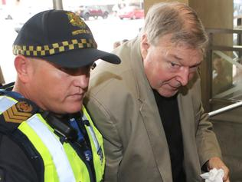](https://www.theaustralian.com.au/inquirer/victorias-shame-police-and-justice-system-broken/news-story/d4bc29833699ecc9ffd3e25cc7891f18)

[Victoria’s shame: police and justice system ‘broken’](https://www.theaustralian.com.au/inquirer/victorias-shame-police-and-justice-system-broken/news-story/d4bc29833699ecc9ffd3e25cc7891f18)

By GERARD HENDERSON

* [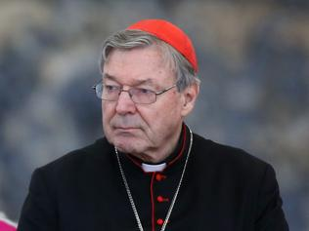](https://www.theaustralian.com.au/nation/george-pells-final-gift-to-priests-family-and-friends/news-story/8f239a3b3496c08cac534571c1a7dbac)

[Pell’s will reveals parting gifts](https://www.theaustralian.com.au/nation/george-pells-final-gift-to-priests-family-and-friends/news-story/8f239a3b3496c08cac534571c1a7dbac)

By DAMON JOHNSTON

**Topics**

* [Cardinal Pell](https://www.theaustralian.com.au/topics/cardinal-pell)

READ NEXT

The clock is ticking for money-saving and tax refund-boosting strategies before the end of financial year. Try these experts’ tips.

ANTHONY KEANE

[EDITORIALS](https://www.theaustralian.com.au/commentary/editorials)

[Actor’s rant will not help Biden](https://www.theaustralian.com.au/commentary/editorials/actors-rant-will-not-help-biden/news-story/b55690c031651d8e6b51028bdff4f1fb)

There is an argument to be made against Donald Trump, but Robert De Niro’s irrational insults did not make it.

EDITORIAL

[LETTERS](https://www.theaustralian.com.au/commentary/letters)

[Half-hearted responses on anti-Semitism](https://www.theaustralian.com.au/commentary/letters/last-post-halfhearted-responses-on-antisemitism/news-story/7c21778d36bf72771369fea7e5c8f85e)

The Prime Minister’s performance on Josh Frydenberg’s documentary gave no confidence that he will put a stop to the hatred.

SPONSORED CONTENT

[Is this the ultimate date night idea?](https://www.couriermail.com.au/sponsored/5f5c852eb083cf7a5ae206b8747ccf96/disneys-beauty-and-the-beast-enchants-brisbane-audiences-with-tale-as-old-as-time/?=v2&obOrigUrl=true" \t "_blank)**[SPONSORED](https://www.couriermail.com.au/sponsored/5f5c852eb083cf7a5ae206b8747ccf96/disneys-beauty-and-the-beast-enchants-brisbane-audiences-with-tale-as-old-as-time/?=v2&obOrigUrl=true" \t "_blank)**[Indulge in a night on the town with these enchanting Beauty and the Beast inspired cocktails and dining offerings.](https://www.couriermail.com.au/sponsored/5f5c852eb083cf7a5ae206b8747ccf96/disneys-beauty-and-the-beast-enchants-brisbane-audiences-with-tale-as-old-as-time/?=v2&obOrigUrl=true" \t "_blank)

[The shoes that will make you run better](https://www.bodyandsoul.com.au/sponsored/AYMEYu8ktUUQFuML2SIR/how-the-right-gear-can-help-you-hit-your-stride/?obOrigUrl=true" \t "_blank)**[SPONSORED](https://www.bodyandsoul.com.au/sponsored/AYMEYu8ktUUQFuML2SIR/how-the-right-gear-can-help-you-hit-your-stride/?obOrigUrl=true" \t "_blank)**[While one of the best parts about running is that it's free, when you start taking it seriously, things get a little more complex.](https://www.bodyandsoul.com.au/sponsored/AYMEYu8ktUUQFuML2SIR/how-the-right-gear-can-help-you-hit-your-stride/?obOrigUrl=true" \t "_blank)

259 COMMENTS

By posting a comment you are accepting our [commenting guidelines](https://www.theaustralian.com.au/support#comment-guidelines) and acknowledge that your use of the site is subject to our site's [terms and conditions](https://www.theaustralian.com.au/termsconditions). If you believe a comment has been rejected in error, email [comments@theaustralian.com.au](mailto:comments@theaustralian.com.au) and we'll investigate. Please ensure you include the email address you use to log in, so we can locate your comment.

Hi John

A NOTE ABOUT RELEVANT ADVERTISING: We collect information about the content (including ads) you use across this site and use it to make both advertising and content more relevant to you on our network and other sites. This is also known as Online Behavioural Advertising. You can [**find out more about our policy and your choices, including how to opt-out here**](http://www.newscorpaustraliaprivacy.com/).

[Back to top](https://www.theaustralian.com.au/world/free-church-from-toxic-nightmare-george-pells-last-warning-to-pope-francis/news-story/26409b3e1b21e3ccb2c3a334b1aa0665)