31 May 2018

Ms Lana Turvey-Collins

Plenary Council Facilitator

PO Box 747

North Sydney NSW 2059

Dear Ms Turvey-Collins,

Please find attached the summary of issues suggested by the New Perspectives for Catholic Education Group to the 2020 Plenary Council of the Australian Catholic Bishops, together with supporting submissions and attachments, as follows:

Attachment A List of matters requiring attention in more detail

Attachment B Submission on Sacramental Program for Reconciliation

Attachment C Submission on Sacramental Program for Eucharist

Attachment D Submission on Individual Morality

Attachment E Submission on a Social Morality policy for the Church

Attachment F Submission on proposed changes to the text books: *To Know, Worship and Love*

Attachment G Submission on how to get our message across at State Schools without offending various education departments’ policies on “age appropriateness” and “sensitivity”

Attachment H Submission that management of the Church should be performance based.

Attachment I Bishops’ 1998 Media Release on GST

Attachment J Catholic Weekly articles of 24 and 31 May 2015

Attachment K Mass Attendance Bar Chart showing the trend since 1947

Attachment L Lists of Signatories Details

Attachment M Diagram of Salvation Approach

Attachment N Diagram of Discipleship Approach

Attachment O Letter to Archdiocese of Sydney on Sacramental programs for Reconciliation and Eucharist

Could you please confirm in writing, by email or by letter, that our documents have been received by the Plenary Council’s Facilitation team?

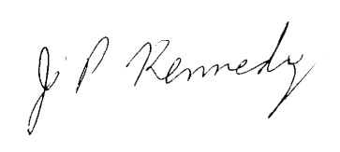Yours faithfully,

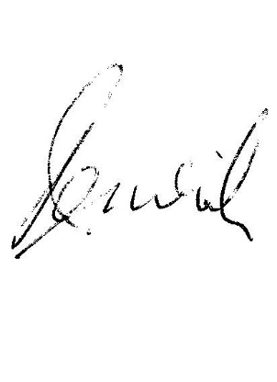

**Signed by:** John Kennedy

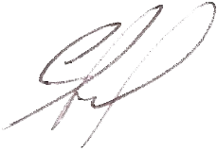Peter Beswick

Professor Garrick Small

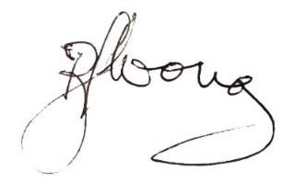

Reg Wong

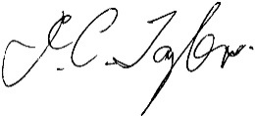

John Taylor

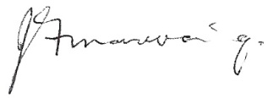

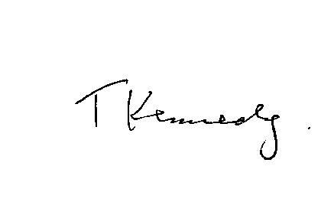James Manwaring

Terrence Kennedy

**Members of the New Perspectives for Catholic Education Group**

**(Contact details are on the spreadsheet attached)**