* [Opinion](https://www.catholicweekly.com.au/category/opinion/)

Counting Catholics: The power of the national Mass attendance survey

By

[**Monica Doumit**](https://www.catholicweekly.com.au/author/monica-doumit/)

-

May 22, 2016

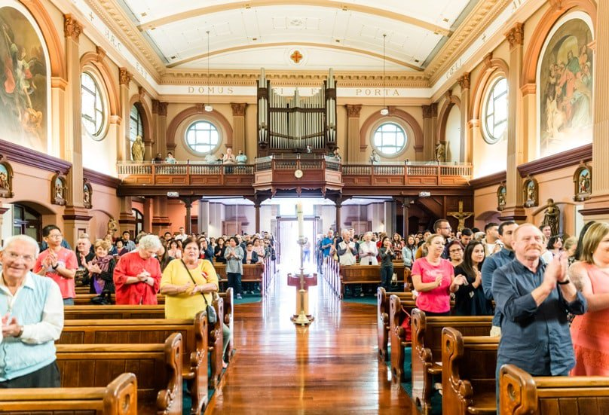The number of faithful attending Mass has been counted over a period of weeks at parishes around Australia, including St Vincent’s, Ashfield (pictured). Photo: Alphonsus Fok

Over the past few weekends, you might have noticed people attempting discreetly to conduct a headcount of those attending Sunday Mass in your parish.

Every five years, the Pastoral Research Office of the Australian Catholic Bishops’ Conference asks for a count to be done over a period of four weekends to determine how many people are attending Mass on a regular basis. The data is then collated and we are presented with statistics on a diocesan, statewide and national level.

This count, which occurs in the same year as the national Census and also the National Church Life Survey, can better inform planning and ministry.

The last national count of Mass attendance reported that about 662,000 people – or 12.2 per cent of the Catholic population – attend Mass each week.  
I don’t know about you, but the realisation that there are hundreds of thousands of Mass attending Catholics out there is a pretty comforting thought.

While Mass-goers may be in the minority, an army of 662,000 is a pretty significant minority. There is safety in numbers.

But where there is safety, there can also be complacency. We can think that with so many practising Catholics out there, we can afford to relax a little when it comes to witnessing to our faith.

But looking at the numbers another way, they don’t seem that big at all.

In 2011, the national count of Mass attendance reported that there were 98,308 regular Mass attendees in the Sydney archdiocese from a total Catholic population of 611,431 and a total population of 2,223,104.

This means that 4.4 per cent of Sydneysiders attend Mass each week. Rounding up, we can say that roughly five in 100 people in Sydney go to Mass on Sundays.

But the statistics also tell us that two out of these five in each 100 are either under the age of 15 or over the age of 65, meaning that they are not usually in the workplace (although I do note that an increasing number of people remain at work after reaching retirement age).

On average, it leaves us with – at best – three in 100 people of working age who attend Mass on Sundays.

If we take out of that all the people who staff our archdiocese, Catholic schools, hospitals and other care facilities, social outreach programs like St Vincent de Paul, those who are stay-at-home parents or the unemployed, the number of Mass-going Catholics participating in the secular education fields or workplaces reduces again.

In a secular workplace or university or TAFE of 100 people, there might be only one practising Catholic.

We might not realise it, particularly in some of our great parishes or other communities, but being a practising Catholic is less common than having a peanut allergy! Before looking at the statistics, it had never occurred to me that the majority of people do not have a practising Catholic among their circle of close friends.

If you are studying or working in a secular environment, you might be the first or the only practising Catholic a person you work or study with will ever encounter. This is both an immense challenge and an immense responsibility, because you might be the only contact someone ever has with the Church.

A singular Catholic has the opportunity to shape a person’s experience and opinion of the Church. Outside of individual Catholics who they meet, people’s opinion of the Church is largely shaped by what they read in the media (and we all know how well-balanced the media coverage of the Church is!).

Encountering a practising Catholic who is in love with their faith and with the Church can go a long way to dispel some of this negativity.

While these considerations are important from the Church’s perspective, they are even more crucial for the people we work with because we know that life is made richer when we encounter God and His Church.

It has been my experience that people are desperate for some of the things we take for granted. They know deep down that financial or other success isn’t enough to satisfy them, but they don’t know where to look for anything else.

That’s where meeting a Catholic who takes their faith seriously can make such a huge and lasting impact.

While we can be tempted to think of “evangelisation” in terms of an event or project or initiative, we can all evangelise. God will use whatever work or study situation we are in, led there by whatever gifts and talents and desires He has given us, to reach out to people who otherwise might not get to encounter Him.

The national count of Mass attendance is a reminder of our responsibility to bring the Gospel to the ends of the earth.

Previous article[Brazilian churches ban communion on the tongue after swine flu deaths](https://www.catholicweekly.com.au/brazilian-churches-ban-communion-on-the-tongue-after-swine-flu-deaths/)

Next article[#myYMT: ‘To say I saw lives change seems so clichéd, but it was true’](https://www.catholicweekly.com.au/myymt-to-say-i-saw-lives-change-seems-so-cliched-but-it-was-true/)

[](https://www.catholicweekly.com.au/author/monica-doumit/)

[**Monica Doumit**](https://www.catholicweekly.com.au/author/monica-doumit/)

Monica Doumit is the Director, Public Affairs and Engagement for the Archdiocese of Sydney and a columnist with The Catholic Weekly.

- Advertisement -

[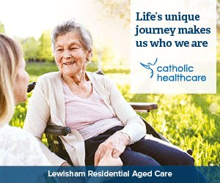](https://www.catholicweekly.com.au/linkout/20230)

FEATURES

[](https://www.catholicweekly.com.au/writing-to-answer-lifes-big-questions/)

[**Arts & Entertainment**](https://www.catholicweekly.com.au/category/news/arts-entertainment/)

[Writing to answer life’s big questions](https://www.catholicweekly.com.au/writing-to-answer-lifes-big-questions/)

[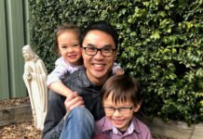](https://www.catholicweekly.com.au/a-vision-for-living-vibrant-and-evangelising-parishes/)

[**News**](https://www.catholicweekly.com.au/category/news/)

[A vision for living, vibrant and evangelising parishes](https://www.catholicweekly.com.au/a-vision-for-living-vibrant-and-evangelising-parishes/)

[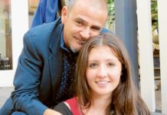](https://www.catholicweekly.com.au/a-fathers-plea-to-all-parents/)

[**Features**](https://www.catholicweekly.com.au/category/features/)

[A father’s plea to all parents](https://www.catholicweekly.com.au/a-fathers-plea-to-all-parents/)

[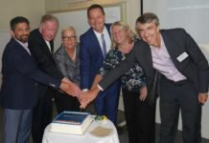](https://www.catholicweekly.com.au/new-social-services-body-launched/)

[**NSW**](https://www.catholicweekly.com.au/category/news/nsw/)

[New social services body launched](https://www.catholicweekly.com.au/new-social-services-body-launched/)

[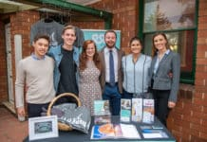](https://www.catholicweekly.com.au/lifechoice-australia-opens-office/)

[**Health & Wellbeing**](https://www.catholicweekly.com.au/category/features/health-wellbeing/)

[LifeChoice Australia opens office](https://www.catholicweekly.com.au/lifechoice-australia-opens-office/)

[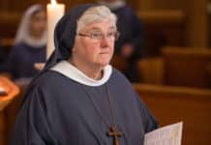](https://www.catholicweekly.com.au/sr-hilda-scott-installed-as-abbess-at-jamberoo-abbey/)

[**News**](https://www.catholicweekly.com.au/category/news/)

[Sr Hilda Scott installed as Abbess at Jamberoo Abbey](https://www.catholicweekly.com.au/sr-hilda-scott-installed-as-abbess-at-jamberoo-abbey/)

MOST POPULAR

[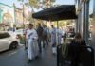](https://www.catholicweekly.com.au/beauty-and-bemusement-as-parishes-take-corpus-christi-to-the-suburbs/)

[Beauty and bemusement as parishes take Corpus Christi to the suburbs](https://www.catholicweekly.com.au/beauty-and-bemusement-as-parishes-take-corpus-christi-to-the-suburbs/)

June 1, 2016

[](https://www.catholicweekly.com.au/the-fiery-maronites-people-of-faith-and-generosity/)

[The “fiery” Maronites: people of faith and generosity](https://www.catholicweekly.com.au/the-fiery-maronites-people-of-faith-and-generosity/)

October 16, 2018

[](https://www.catholicweekly.com.au/my-husband-works-at-home-and-now-he-knows/)

[Simcha Fisher: My husband works at home and now he knows](https://www.catholicweekly.com.au/my-husband-works-at-home-and-now-he-knows/)

October 17, 2018

[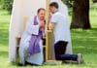](https://www.catholicweekly.com.au/seal-law-doesnt-add-up/)

[Monica Doumit: Seal law doesn’t add up](https://www.catholicweekly.com.au/seal-law-doesnt-add-up/)

October 11, 2018

- Advertisement -